OUT ON MARCH 18th

CLICK ON THE IMAGE BELOW TO ACCESS THE FIRST SINGLE RELEASE “SIGNS”

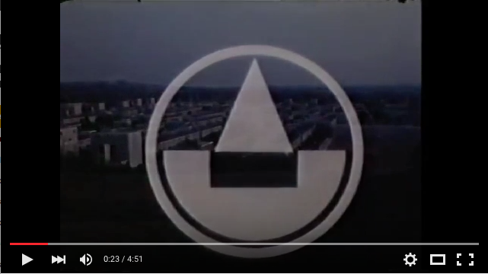

Skelmersdale in West Lancashire was designated a new town in 1961. Part of the UK’s second wave of post-war population redistribution, it was failing within twenty years. Another Northern town facing up to the realities of the Thatcher era, Skem (as it’s known locally) saw house prices spiral down and unemployment figures rise. Prospects for Skelmersdale looked decidedly gloomy until some unlikely saviours stepped in.
In the early ’80s, Skem became the official UK home of the Transcendental Meditation movement. Geographically placed somewhere near the centre of the country, the town was deemed the perfect site for the movement to build their ‘ideal maharishi village complete with gold meditation dome’ (the Guardian). The local community was soon augmented by families from across the country looking to live peaceful, peace-promoting lives with an overriding ambition to spread goodwill to the town and beyond.
Simon Tong was a child of one of those families. “We moved there in 1984 from Bolton. My dad wanted to be a part of the TM movement in the town. He wasn’t ever a hippie; he’d been more of a beatnik in the ’60s. Growing up in Skem as a teenager, I hated the whole TM thing. When I got to 16 and started practising it for a few years, it worked. I became a lot less miserable and angry.”
Two decades later, Tong is one third of the Magnetic North (the occasional musical collaboration between Tong, Erland Cooper and Hannah Peel). Having played together in bands for several years, the Magnetic North came together when the concept for an entire album – 2013’s Orkney: Symphony of the Magnetic North - arrived fully formed in a dream that Tong’s Orcadian band mate Cooper experienced.
A nocturnal visitation from the ghost of legendary Betty Corrigall had left Cooper with an album’s worth of song titles that would eventually form an imagined soundtrack to the island. The record was both a distinctive treatise on place (and one’s relationship to it) and a gorgeous, soaring widescreen interplay between Tong, Cooper and Peel.
Erland: “When I told Simon about the dream, I expected him to say, “Fuck off, you’re mad” but he was up for talking more. The landscape of Orkney would dictate how the record sounded; it meant that couldn’t help being grand.”
After a period working on other projects (Cooper and Tong are two thirds of Erland & the Carnival, Peel is a solo artist and busy composer), thoughts turned to a follow-up to the Orkney record. Peel suggested they search Tong’s hometown for inspiration.
Hannah: “I said to Simon that we should all go to Skem and see if anything came to us. He humoured us and wrote Erland and I a road map with a paragraph on each place. It was hilarious - truthful and a little bit ruthless.”
Simon: “There was a vague idea about writing something about what I was from. It must have seemed exotic to Erland and Hannah. Skelmersdale is this weird evocative Nordic name, it’s a new town and it has the whole TM thing. Our first attempts just didn’t work though.”
Erland: “Every time we tried to tackle it, we’d ask ourselves whether we were actually taking the piss. That was the one thing we didn’t want to do – write an album of slum porn. We wrote twenty or thirty tunes that just felt like mush. We took ourselves off to Eskdale where Simon used to holiday as a kid and we pooled a bunch of material. It felt really good to look at the record and throw what wasn’t working in the bin.”
Simon: “Starting again from scratch was liberating. We’d realised that to make the record click, there had to be hope and positivity.”
Erland: “Death In The Woods was the turning point. It’s about a boy, going to meet his mates on a crappy bus on his way to a crappy location, just being a kid. There’s spit on the windscreen, shit on the pavement. It’s someone’s life. Lyrically, that song set the record on its course.”
If Orkney… is the musical equivalent of great nature writing then Prospect of Skelmersdale is somewhere between finely tuned kitchen sink drama and urban psychogeography. Inspired as much by the greys and greens of Kes as the soothing, cyclical patterns of meditative ragas, Prospect of Skelmersdale is a collection of musical snapshots of a uniquely British town. Across the record, Cooper and Peel’s voices swap, swoop and interweave to create an utterly immersive and believable narrative about the town and its people.
Simon: “We wanted to start the record with the laying of the foundation stone of the TM temple. The opening track’s title - Jai Gurudev – is from the name of the original guru to the Maharishi. His name is used a blessing when entering someone’s house in the town. Starting the album there felt like we were giving the record a blessing”
(The phrase also features in the lyrics to Across the Universe. Prospect of Skelmersdale closes with a cover of George Harrison’s Run of the Mill, a nod towards his position as the most famous early advocate of TM).
Gathering together archived news stories, dim-lit memories, directions from road signs, local graffiti and tales from the town’s dual modern histories, Cooper, Tong and Peel beautifully detail tales of hope that look in two opposing directions – the hopefulness of the newly arrived is echoed the more desperate hopes of those trying to leave. Sonically, the trio used orchestration sparingly in order to create something of a
Hannah - “The minute you start playing with orchestral arrangements, things can go to pomp. The Orkney record is a record to travel to; go to Orkney, walk around it. It needed to be cinematic and symphonic because the landscape is. But with the new album we wanted to avoid it being overblown and try to create something that could be the soundtrack to a ’70s BBC play or documentary. Music that felt granular and a bit odd. Not cinematic, something far more home grown, small-screen.”
Simon: “I’d been reading about Dennis Potter growing up in the Forest of Dean and the effect that his fanatical religious upbringing had on him. He ended up ascribing Biblical locations to places where he walked and played. I think we’re trying to do something similar; trying to create magic and mythology in the places we grew up – the kind of magic that maybe as a resident you only glimpse occasionally.”
The Magnetic North are a true one-off; a questing band who’ve made two peerless albums – wholly evocative musical travelogues each tracing song lines around the geographical heritage of one of the band’s members.
And Hannah’s history? Born in 1980s Northern Ireland, grew up in Barnsley.

Now, just imagine that record…

Prospect of Skelmersdale is released on Full Time Hobby on March 18th. For more information, contact Antoine Corman : antoine@fulltimehobby.co.uk

https://twitter.com/magneticgonorth
https://www.facebook.com/themagneticnorth
http://www.symphonyofthemagneticnorth.com/

Full Time Hobby, 2nd Floor, Unit 19, Tileyard Road London N7 9AH
- http://www.fulltimehobby.co.uk - PHONE : 02075356740

